Day 21: 13 Aug 2026
Home Task:
- What is the difference between Node.js and a traditional web server like Apache or Nginx?

Feature | Node.js | Apache / Nginx
Type | JavaScript runtime | Web server
Main purpose | Run JavaScript on the server | Serve web pages/files and handle HTTP requests
Programming | JavaScript / TypeScript | Usually works with applications written in other languages
Architecture | Event-driven, non-blocking | Apache traditionally process/thread-based; Nginx event-driven
Best for | APIs, real-time apps, backend services | Static files, reverse proxy, load balancing, web hosting
Package ecosystem | npm | Modules/configuration
Example | Express.js API | Nginx serving React build files

Browser
↓
Nginx
↓
Node.js / Java / Python application

- Explain the event-driven architecture of Node.js.

Event-driven architecture means that Node.js works by waiting for events and responding to them when they occur, instead of creating a separate thread for every request.
• Node.js starts reading the file.
• Instead of blocking and waiting, Node.js continues executing the next statement.
• When the file is finished, Node.js receives the completion event.
• The callback is executed.
Node.js is event-driven and non-blocking: it starts asynchronous operations and uses the event loop to handle their completion without blocking the main JavaScript thread.

- How does the single-threaded model in Node.js handle concurrency?
Node.js uses a single main JavaScript thread to execute JavaScript code. It handles many operations concurrently using the event loop and asynchronous, non-blocking I/O.
Request 1 ──┐
Request 2 ──┤
Request 3 ──┼──> Event Loop ──> Execute callbacks
Request 4 ──┤
Request 5 ──┘

- What is the role of the V8 engine in Node.js?
The V8 engine is the JavaScript engine developed by Google. It is the component that executes JavaScript code in Node.js.
V8 | Node.js
JavaScript engine | JavaScript runtime
Executes JavaScript | Provides environment to build server applications
Developed by Google | Built around V8
Handles JIT compilation | Provides APIs such as HTTP, filesystem, networking
Handles garbage collection | Provides event loop and Node-specific APIs
- Why is Node.js considered non-blocking?
Node.js is considered non-blocking because it does not wait for slow I/O operations to finish before continuing with other JavaScript code.
Instead, Node.js starts the operation asynchronously and continues executing. When the operation completes, the event loop handles the result.

- What is the difference between callbacks, promises, and async/await in Node.js?
Feature | Callback | Promise | async/await
Style | Function passed to another function | Represents future result | Cleaner syntax built on Promises
Readability | Can become difficult | Better | Usually easiest
Error handling | if (err) | .catch() | try...catch
Chaining | Can cause callback nesting | .then() chaining | Sequential-looking code
Modern usage | Older/common APIs | Modern | Most commonly preferred
Based on | Functions | Promise object | Promises

- How does the event loop work, and what are its phases?
The Event Loop is the mechanism that allows Node.js to handle asynchronous, non-blocking operations even though JavaScript execution happens on a single main thread.
Node.js
│
↓
JavaScript Code
│
↓
Event Loop
↙ ↘
Synchronous Async I/O
work operation
│
File / DB / Network
│
↓
Completion
│
↓
Event Loop
│
↓
Execute callback

- What is the difference between process.nextTick() and setImmediate()?
Both are used to schedule code to run after the current synchronous code finishes, but they are handled at different points in Node.js's execution cycle.
Feature | process.nextTick() | setImmediate()
Executes | Before the event loop continues to its next phase | During the Check phase
Priority | Very high | Lower than nextTick()
Event loop phase | Not technically an event-loop phase | Check phase
Typical use | Run something immediately after current operation | Schedule work for the next event-loop iteration
Can starve event loop? | Yes, if recursively abused | Much less likely

nextTick() runs after the current synchronous code finishes, before the event loop proceeds further.

Current JavaScript
↓
process.nextTick()
↓
Continue event loop

setImmediate() schedules the callback for the Check phase of the event loop.
Event Loop
↓
Timers
↓
Pending callbacks
↓
Poll
↓
Check
↓
setImmediate() callback

Typical Flow:
Start
End
nextTick
setImmediate

- How does Node.js handle I/O operations asynchronously?
Node.js handles I/O operations asynchronously and non-blocking, meaning the main JavaScript thread does not wait for slow operations like file access, network requests, or database operations to finish.

- How does the require() function work internally?
require() is the CommonJS module system used by Node.js to load modules.
require("module")
↓
1. Resolve module
↓
2. Load module
↓
3. Wrap module
↓
4. Execute module
↓
5. Cache module
↓
6. Return module.exports

- What is the purpose of package.json and package-lock.json?

File | Purpose
package.json | Describes the project and declares its dependencies
package-lock.json | Locks the exact versions of dependencies installed
package.json contains project metadata, scripts, and the dependency version ranges required by a Node.js application. package-lock.json records the exact dependency versions and dependency tree resolved by npm. package.json describes what the project needs, while package-lock.json helps ensure that everyone installs the same dependency versions.

- Explain the difference between dependencies and devDependencies in npm.
Feature | dependencies | devDependencies
Purpose | Required to run the application | Required for development
Production | Needed | Usually not needed
Examples | Express, Mongoose, Axios | Jest, Nodemon, ESLint
Install command | npm install package | npm install package --save-dev
package.json section | "dependencies" | "devDependencies"
Dependencies are packages required by the application at runtime, such as Express or Mongoose. DevDependencies are packages primarily required during development, testing, or building, such as Jest, ESLint, and Nodemon. They are separated so production environments don't need to install development-only tools.

Task 1:
Create a common js module in nodejs to do some arithmetic operation.
// calculator.js

function add(a, b) {
return a + b;
}

function subtract(a, b) {
return a - b;
}

function multiply(a, b) {
return a * b;
}

function divide(a, b) {
if (b === 0) {
return "Cannot divide by zero";
}
return a / b;
}

// Export functions
module.exports = {
add,
subtract,
multiply,
divide
};

// app.js

const calculator = require("./calculator");

console.log("Addition:", calculator.add(10, 5));
console.log("Subtraction:", calculator.subtract(10, 5));
console.log("Multiplication:", calculator.multiply(10, 5));
console.log("Division:", calculator.divide(10, 5));

Task 2:
Create the same task 1 code using ecmascript.
// operations.js

export function add(a, b) {
return a + b;
}

export function subtract(a, b) {
return a - b;
}

export function multiply(a, b) {
return a * b;
}

export function divide(a, b) {
if (b === 0) {
return "Cannot divide by zero";
}

return a / b;
}

// main.js

import {
add,
subtract,
multiply,
divide
} from "./operations.js";

console.log("Addition:", add(10, 5));
console.log("Subtraction:", subtract(10, 5));
console.log("Multiplication:", multiply(10, 5));
console.log("Division:", divide(10, 5));

Task 4:
Given 2 files app.js and home.js
Can you let me know we are doing in this code.. Give comments for this code in your document.

app.js
// app.js

const express = require('express')
const bodyParser = require('body-parser')
const notes = [{
noteId: 1,
noteContent: "Hey, Prasunamba you can add your important notes here."
}
]

const app = express()

// using ejs render html templates dynamically
app.set('view engine', 'ejs')

app.use(bodyParser.json());
app.use(bodyParser.urlencoded({
extended: true
}))
// adding a middle to parse form data

app.get("/", function (req, res) {
// sending home template with data notes
res.render("home", {
data: notes
})
})

app.post("/", (req, res) => {
const noteContent = req.body.noteContent
const noteId = notes.length + 1;

notes.push({
noteId: noteId,
noteContent: noteContent
})

res.render("home", {
data: notes
})
})

app.post('/update', (req, res) => {
var noteId = req.body.noteId;
var noteContent = req.body.noteContent;

notes.forEach(note => {
if (note.noteId == noteId) {
note.noteContent = noteContent;
}
})
res.render("home", {
data: notes
})
})

app.post('/delete', (req, res) => {
var noteId = req.body.noteId;

var j = 0;
notes.forEach(note => {
j = j + 1;
if (note.noteId == noteId) {
notes.splice((j - 1), 1)
}
})

res.render("home", {
data: notes
})
})

app.listen(3000, (req, res) => {
console.log("App is running on port 3000")
})

home.js

<!DOCTYPE html>
<html>

<head>
<title>Note Keeper</title>
</head>

<body>
<h1>Note Keeper</h1>

<div style="display: flex;">

<% data.forEach(element=> { %>

<form action="/update" method="post">
<input type="number" style="display: none;"
name="noteId" value="<%= element.noteId %>">
<textarea type="text" rows="6" cols="30"
placeholder="Type Here..." name="noteContent"
value="<%= element.noteContent %>">
<%= element.noteContent %></textarea>
<br>
<button type="submit">Update</button>
</form>

<form action="/delete" method="post">
<input type="number" style="display: none;"
name="noteId" value="<%= element.noteId %>">
<button type="submit"
style="margin: 0px 4px;">&#10005</button>
</form>
<% }) %>
</div>

<h1>Add Note</h1>
<form action="/" method="post">
<input type="number" style="display: none;"
name="noteId">
<textarea type="text" rows="6" cols="30"
placeholder="Type Here..."
name="noteContent"></textarea>
<br>
<button type="submit">Add</button>
</form>
</body>

</html>
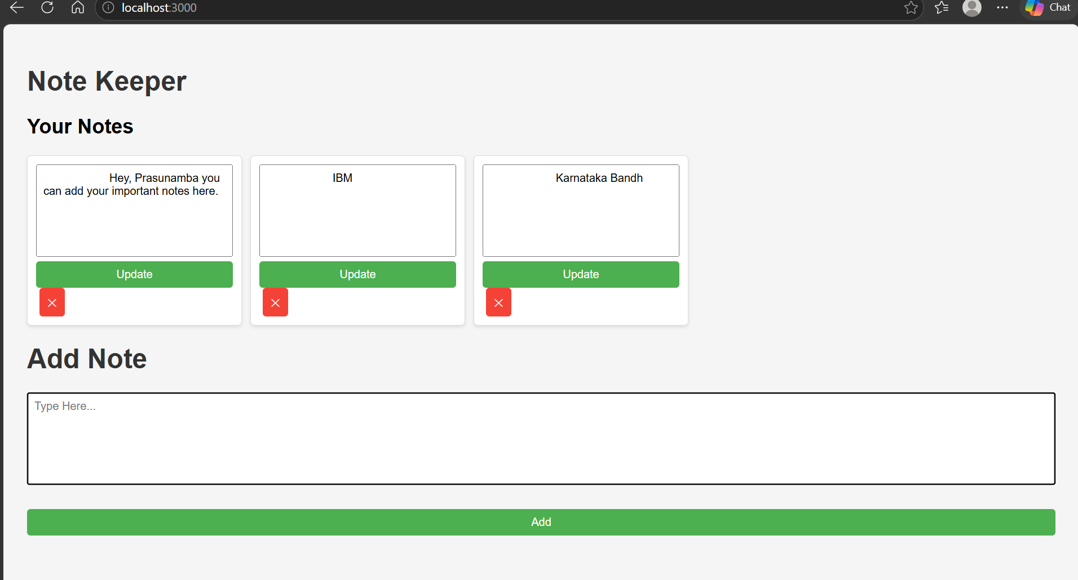

Task 5:
- Import all the required modules like express…
- Initialize the express app
- Create a async function for getting weather.
  - Use await Fetch for `https://api.openweathermap.org/data/2.5/weather?q=${city}&appid=${process.env.WEATHER_KEY}&units=metric`
And assign to response.
- Now convert response to json..
- Then return weather info like city , forecast. Temp…etc..
- Iff any error catch it in catch block
- Next call the web server route.
Like sample
app.get('/weather', async (req, res) => {
const city = req.query.city || "Bengaluru"; // default city
const weatherData = await getWeather(city); // async call
res.json(weatherData); // send JSON response
});

- Finally start the server.

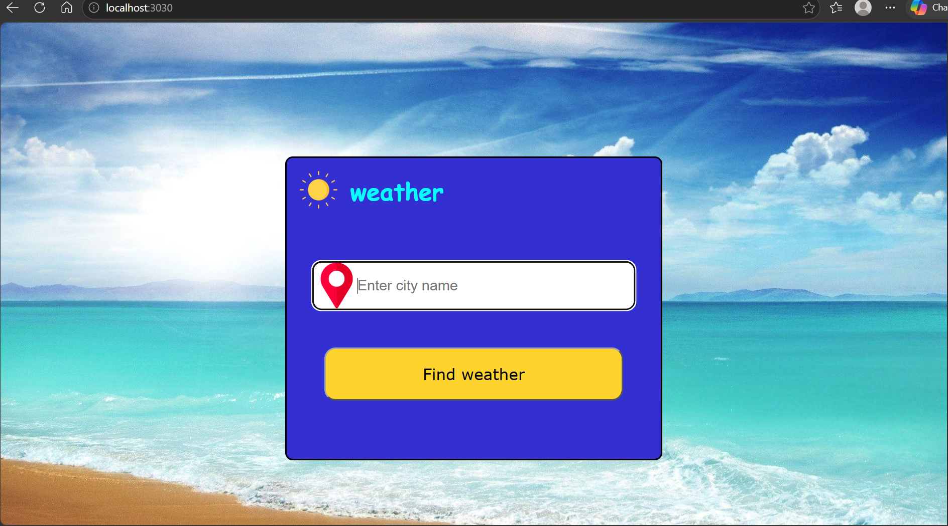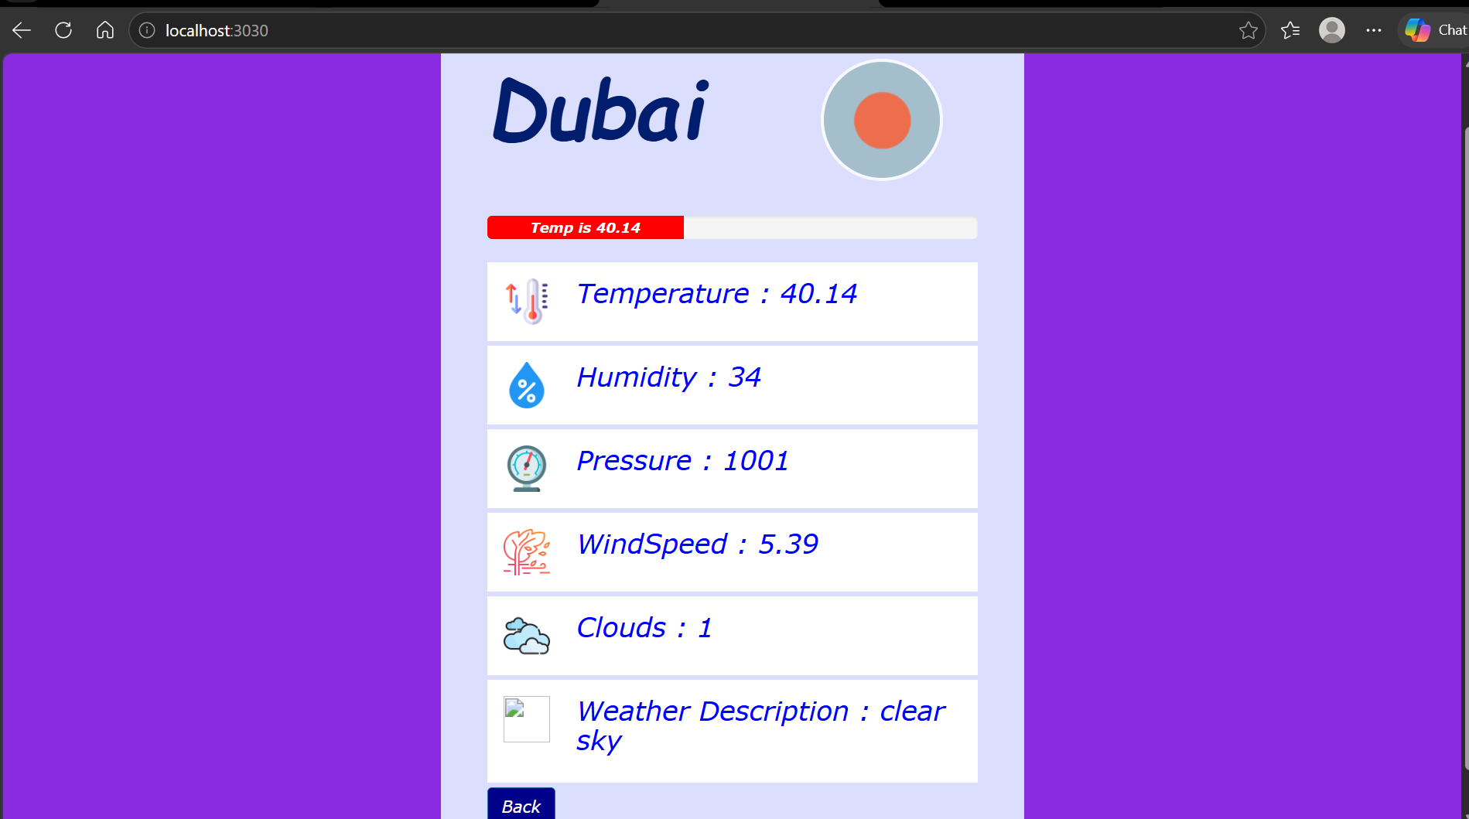

Task 6:
What is Mongoose? What are the key features?why do we use ?
Mongoose is an ODM (Object Data Modeling) library for MongoDB and Node.js
It provides a structured way to work with MongoDB from a Node.js application.
Without Mongoose, we can communicate with MongoDB using the MongoDB driver directly. Mongoose adds features such as schemas, models, validation, and middleware, making database operations easier to organize.

Feature | Description
Schema | Defines the structure of documents
Model | Provides an interface to interact with a MongoDB collection
Validation | Validates data before saving it
CRUD Operations | Supports Create, Read, Update, and Delete
Middleware | Allows logic to run before/after database operations
Relationships | Supports references between documents using ObjectId
Query Building | Provides convenient methods for MongoDB queries
Type Casting | Automatically converts values to appropriate types

Task 7:
Is this statement true or false?
Mongoose acts as a bridge between Node.js and MongoDB, giving you a structured way to manage your data.
The statement is true.
Mongoose acts as a layer between your Node.js application and MongoDB. It provides features such as:
- Schemas → Define the structure of your data.
- Models → Interact with MongoDB collections.
- Validation → Ensure data meets required rules.
- CRUD operations → Create, read, update, and delete data.
- Middleware → Execute logic before or after database operations.

Task 8:
Now in your project
- Import mongoose
- Connect to mongodb
- Lets define a schema..
Like
const userSchema = new mongoose.Schema({
name: String,
age: Number,
email: { type: String, required: true }
});

- Now create a model
const User = mongoose.model('User', userSchema);
- Insert a document
// Insert a document
const newUser = new User({ name: 'Prasunamba', age: 30, email: 'prasun@example.com' });

newUser.save()
.then(() => console.log('User saved successfully!'))
.catch(err => console.error(err));
const express=require("express");
const bodyParser=require("body-parser");
const https=require("https");
const mongoose = require("mongoose");
const port=process.env.PORT || 3030;
require("dotenv").config();

const apikey = process.env.WEATHER_API_KEY;
const mongoURI = process.env.MONGODB_URI || "mongodb://127.0.0.1:27017/weatherDB";

const app=express();
app.use(bodyParser.urlencoded({extended:true}));
app.use(express.json());
app.set("view engine","ejs");

mongoose.connect(mongoURI)
.then(() => console.log("Connected to MongoDB"))
.catch((err) => console.error("MongoDB connection error:", err.message));

const userSchema = new mongoose.Schema({
name: String,
age: Number,
email: { type: String, required: true }
});

const User = mongoose.model("User", userSchema);

app.get("/",function(req,res){
res.sendFile(__dirname+"/index.html");
});
app.post("/",function(req,res){

var cityName=req.body.city;
const url="https://api.openweathermap.org/data/2.5/weather?q="+cityName+"&appid="+apikey+"&units=metric";
https.get(url,function(response){

const x=response.statusCode;
if(x>=200 && x<=299)

{
response.on("data",function(data){
const weaterData=JSON.parse(data);
var temp=Number(weaterData.main.temp);
var humidity=Number(weaterData.main.humidity);
var pressure=Number(weaterData.main.pressure);
var windSpeed=Number(weaterData.wind.speed);
var clouds=Number(weaterData.clouds.all);
var city=weaterData.name;
var weatherDescription=weaterData.weather[0].description;

const icon=weaterData.weather[0].icon;
const iconurl="https://openweathermap.org/img/wn/"+icon+"@2x.png";

res.render("result.ejs",{
CityName:city,
temperature:temp,
Humidity:humidity,
Pressure:pressure,
WindSpeed:windSpeed,
Clouds:clouds,
weatherDescription:weatherDescription,
iconurl:iconurl
})
})
}

else
{
res.render("error.ejs",{reason:"city not found"})
}
})

console.log(cityName);
})

app.post("/back",(req,res)=>{
res.redirect("/");
})

app.post("/api/users", async (req, res) => {
const { name, age, email } = req.body;

if (!email) {
return res.status(400).json({ message: "Email is required" });
}

try {
const newUser = new User({ name, age, email });
const savedUser = await newUser.save();
res.status(201).json({
message: "User created successfully",
user: savedUser
});
} catch (error) {
res.status(400).json({
message: "Error creating user",
error: error.message
});
}
});

app.get("/api/users", async (req, res) => {
try {
const users = await User.find();
res.status(200).json(users);
} catch (error) {
res.status(500).json({
message: "Error fetching users",
error: error.message
});
}
});

// multipart or formdat
var multer = require('multer');
var upload = multer();
// // for parsing multipart/form-data
app.use(upload.array("file"));

app.post("/formdata",(req,res)=>{
const body=req.body;
console.log(body)
// console.log(req.file)
const file=req.files[0];
const buffer=file.buffer;
console.log(buffer)
console.log(buffer.toString())
})

app.listen(port,function(){
console.log(`server started width ${port}`)
});

